OCEANA COUNTY 4-H MARKET LIVESTOCK
EDUCATIONAL NOTEBOOK/RECORD

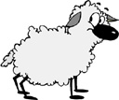

LITTLE BUDDY LAMB PROJECT - 2025

AGES 5 – 7 YEARS

As a member of the 4-H Market Livestock Little Buddy Lamb Project, you are required to submit your records as part of an educational notebook project in order to show your animal at the Oceana County Fair. This notebook must be shown to the Oceana County 4-H Market Livestock Committee’s Weighmaster at the time of weigh-in and then entered by you in the Educational Notebook Division of the Oceana County Fair on Entry Day.

AGE _________

The age you enter depends on how old you are on or will be on January 1, 2025

NUMBER OF YEARS IN PROJECT ________

Use this sheet as the first page of your project record book. Fill it out completely.
Please print or type neatly.

NAME _________________________________________________________________

4-H CLUB _______________________________________________________________

BREED _________________________________________________________________

LAMB’S NAME ___________________________________________________________

NAME OF BIG BUDDY ____________________________________________________



JUDGE’S SCORE/COMMENT SHEET

(PLEASE DO NOT REMOVE, PLACE THIS SHEET IN SHEET PROTECTOR OR GLUE TO COVER). This sheet must be keep free to the judge to write their comments.

This sheet should help each 4-H’er understand their ribbon placing.

A. Specific educational value or worth

___ All questions were answered completely

___ All calculations were correct

___ Calculations were incorrect

___ Questions were not answered (missed questions)

B. Notebook contains all project records

___ Notebook contained all project records and were fully completed

___ Notebook contained additional project related information (research

materials etc.)

___ Project records were incomplete

___There was no additional project related information

C. Accuracy, neatness and general appearance

___Notebook was neat in appearance (typed/hand printed)

___Notebook pages were clean and stain free

___Notebook pages were in order and complete

___Notebook was difficult to read and messy

__Notebook had wrinkled and stained pages

Other Comments: ______________________________________________________

____________________________________________________________________

__________________________________________________________________

LITTLE BUDDY LAMB NOTEBOOK
TABLE OF CONTENTS
Please keep your notebook in Table of Contents order.

- GENERAL GUIDELINE INFORMATON

- ABOUT YOUR LAMB

- JOURNAL OF CARE

- PROJECT INFORMATION

- SPECIFIC PROJECT KNOWLEDGE
  - Lamb Parts

- YOUR PROJECT INFORMATION
a. My 4-H Project
b. 4-H Knowledge

6) PICTURES OF YOUR PROJECT (1 page)

7) CLUB POINT SHEET

APPENDIXES (OPTIONAL):

    - PICTURES OF YOUR PROJECT (additional pictures)

    - FEED INFORMATION (example: feed labels)

    - ADDITIONAL INFORMATION ABOUT YOUR PROJECT
- Information you found in reference materials
- Worksheets done with your 4-H Club
- Information you located off the internet
- Information from your feed representative
- Any other information
* Include notes as to why you researched this information and
found it valuable, link it to your project if possible.

Notebook Resources:

4-H Skills for Life Animal Series – Sheep 1, 2 & 3
(All lamb leaders have a set of these booklets. There is also a set available on a check-out system at the
MSU Extension Office)
Your Sheep – A Kid’s Guide to Raising & Showing (National 4-H Supply)
Lamb Showmanship Handout – MSU Extension
Kansas State 4-H Online Website

**NOTE THIS AGE GROUP DOES NOT REQUIRE POTENTIAL BUYERS. IF YOU INCLUDE THOSE, PLEASE ADD IT TO THE BACK SECTION OF YOUR BOOK.

2025-Little Buddy Lamb Notebook (5-7) Page 1

This record book is part of your 4-H Market Lamb Project. By keeping records up-to-date you will be able to see how much progress you make as you set goals and work to accomplish them. Write neatly and clearly. Feel free to add extra pages.

FAIR ENTRY RULES

If you are between the ages of 5 and 7 years old and elect to participate in a 4-H class at the Oceana County Fair you will be awarded a participation ribbon for your efforts.

In order to compete for an “A”, “B” or “C” Ribbon you will have to enter you record book in the “Open Educational Notebook Class”.

If you have questions, please contact your leader or the MSU Extension Office as fair approaches.

PROJECT PICTURES

Pictures are a required part of this notebook. Taking pictures of your project animal throughout the project will indicate how your animal has grown and developed. Add pictures to your notebook on a separate piece of paper.

SCORING CRITERIA

The following breakdown will be used during the judging process of all market livestock notebooks.

A. Specific educational value or worth 30%

B. Creative way of showing what has been learned 10%

C. Notebook contains all project records 50%

D. Accuracy, neatness and general appearance 10%

The Oceana County 4-H Market Livestock Committee encourages 4-H Leader and parent assistance with your project and project notebook. If you should have any questions, please contact the MSU Extension Office.

I, ____________________________ assisted ________________________ in
Parent/Leader/Adult Name 4-Her’s Name
understanding the questions and writing the answers. All answers are those of the 4-Her.

____________________________________
Signature of person helping with notebook
If written help was needed

2025- Little Buddy Lamb Notebook (5-7) Page 2

ABOUT YOUR LAMB

My Lamb’s name is: ___________________________________________

My Lamb’s breed is: ___________________________________________

What color is your Lamb? ______________________________________

My Lamb’s favorite thing to do is? ________________________________

My Lamb is a (circle one) Wether (boy lamb) Ewe (girl lamb)

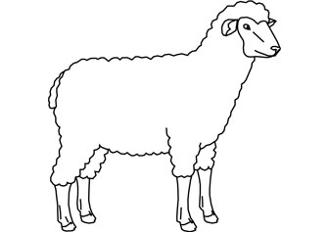

2025- Little Buddy Lamb Notebook (5-7) Page 3

ANIMAL CARE AND MANAGEMENT- JOURNAL OF CARE

Your project requires regular care and management.

Include the following:
- Walking and working with your animal
- Feeding and watering practices
- Grooming (clipping, toenail trimming, washing, etc.)
- Health practices and medicines (vaccinations, etc.)
- General Management (cleaning living area, feed pans, etc.)

Daily- Things done once or twice a day
Weekly- Things done once or twice a week
Monthly- Things done once a month
Yearly- Things done one time or occasionally throughout the year

My little buddy helped me with the care and training of our project animal.

Signature of Big Buddy:___________________________________ Date: ____________

2025- Little Buddy Lamb Record Book (5-7) Page 4

PROJECT INFORMATION

The start of the project will be the date the 4-Her placed the animal on feed, not any later than June 1st of the current year. The end of the project will be weigh-in day at the Fair.

Project Start Date June 1, 2025 Project End Date ________________
Fair haul in day
What month was your lamb born? _________________________

Please complete the following chart about your project. Have your big buddy help you.

Ear Tag  Number | Breed | Gender | Date of Purchase | Price or Value | Estimated  Starting Weight | Ending Weight | Total Pounds Gained
Note: Total pounds gained = ending weight – starting weight

MARKETING

One of the most important parts of any market animal project is marketing. This may include writing letters and talking to prospective buyers. Color in the face, a smiling face is a good action, a frowning face is a bad action. (see the example)

Good Marketing Practice Poor Marketing Practice






Send a picture to your potential buyers

Send a reminder to attend the auction

Let an adult talk to the buyer instead of you talking to them
Know the breed of your animal, if asked

Only ask family members to be potential buyers

Make sure to visit your previous buyers

Only thank those who agree to be listed as a potential buyer

Insult competitors

2025- Little Buddy Lamb Notebook (5-7) Page 5

LAMB PARTS- Color the lamb parts

Breast- Orange Fore shank- Green Neck- Black
Face- Blue Leg- Purple Rack- Pink
Flank- Red Loin- Yellow Shoulder- Brown

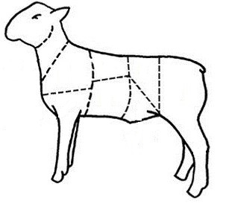

2025- Little Buddy Lamb Notebook (5-7) Page 6

YOUR PROJECT

Please answer the following questions to the best of your ability.

1. What did you have the most fun doing with your project?

______________________________________________________________________________________

______________________________________________________________________________________

______________________________________________________________________________________

______________________________________________________________________________________

2. What was the hardest part of your project?

______________________________________________________________________

______________________________________________________________________

_____________________________________________________________________________________

_____________________________________________________________________________________

3. Will you do a lamb project again?

____________________________________________________________________________________

Why or why not?

_____________________________________________________________________________________

____________________________________________________________________________________

_____________________________________________________________________________________

_____________________________________________________________________________________

2025- Little Buddy Lamb Notebook (5-7) Page 7

4-H KNOWLEDGE
The 4-H Pledge- Draw a line to the picture that fills in the blank (see the example)

I pledge…
HANDS

HEALTH

HEAD

HEART

WORLD

COUNTRY

CLUB

COMMUNITY
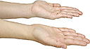









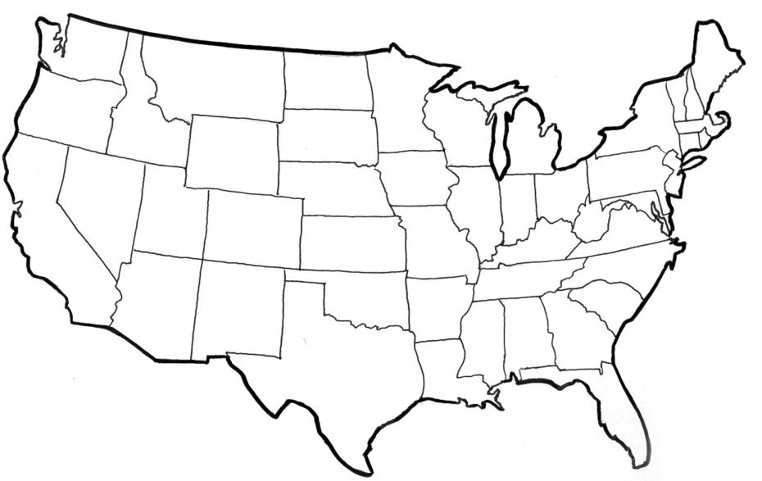

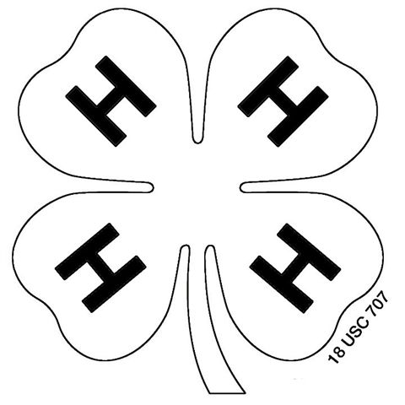



My ____________ to clearer thinking,

My ____________ to greater loyalty,

My ____________ to larger service, and

My _____________ to better living,

for my ____________________,

my _______________________,

my _______________________,

and my ____________________.

2025- Little Buddy Lamb Record Book (5-7) PAGE 8

YOUR PROJECT PICTURES

(Please use this page for your project pictures and tell anything special, that you might want the judge to know, about you and your project animal.

CLUB POINTS
MARKET LIVESTOCK ATTENDANCE RECORD- ALL AGES MUST COMPLETED.
Please note: This form must be included with your record notebook and turned into the weigh master on entry day of the fair. You need to accumulate Six (6) club meetings to be considered as completing your project. Non-club points are optional for this age group and if included should be on separate sheet (available at MSU Extension) and included in the back of your book.
MEETING NAME | LOCATION | DATE | POINTS | SIGNATURE OF LEADER, SUPERINTENDENT OR MSU STAFF

